**SOCIAL NETWORK Ads**

**Description:**

The given problem statement which is social network ads analysis is well fitted using KNN Classifier to get the desired output image.

**Dataset:**

The Social_Network_Ads.csv data consist of User Id, Gender, Age, Estimated Salary, Purchased (purchased the car or not) as features. Out of which we have chosen Age and Estimated salary as independent variable X and Purchased as dependent variable Y. We use the StandardScaler module from the sklearn.preprocessing library to scale all of our independent variables.

**Model:**

After the data is standardized, the KNN Classifier is applied to the data for classification purpose. Because the task is to predict and classify whether a customer buys a car or not. Then to evaluate the results of the classifier, a confusion matrix, accuracy ,precision of the model is shown. Then visualization of the model is done by using the meshgrid function.

**Results & Interpretation:**

Prediction:

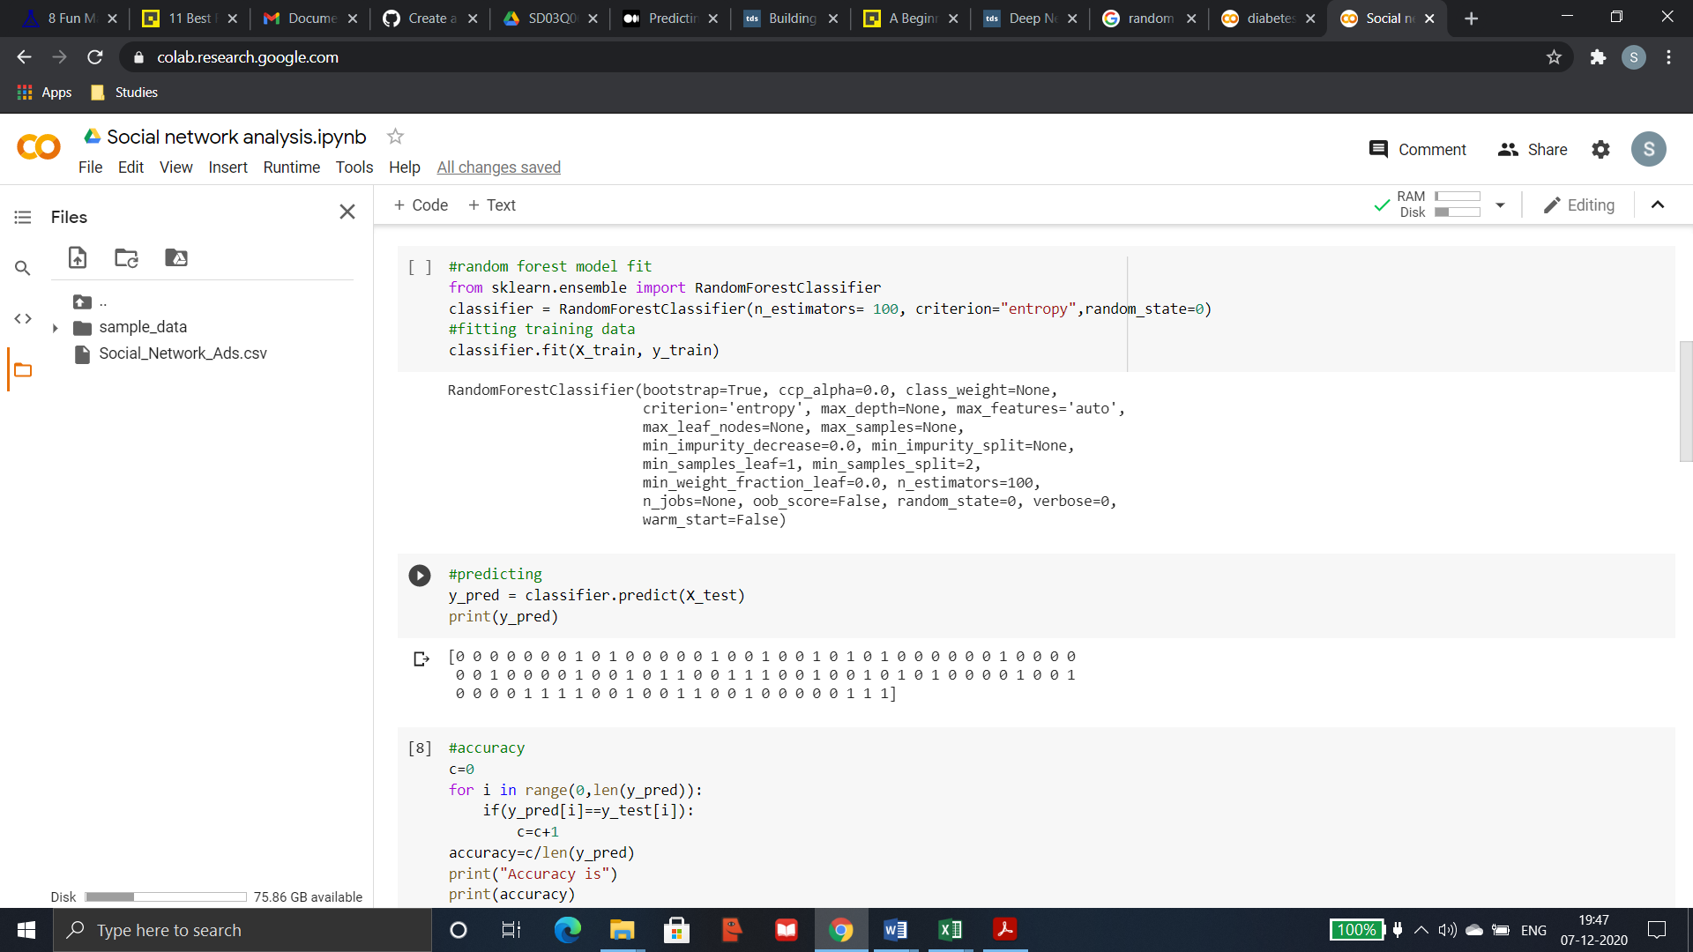

Confusion matrix:

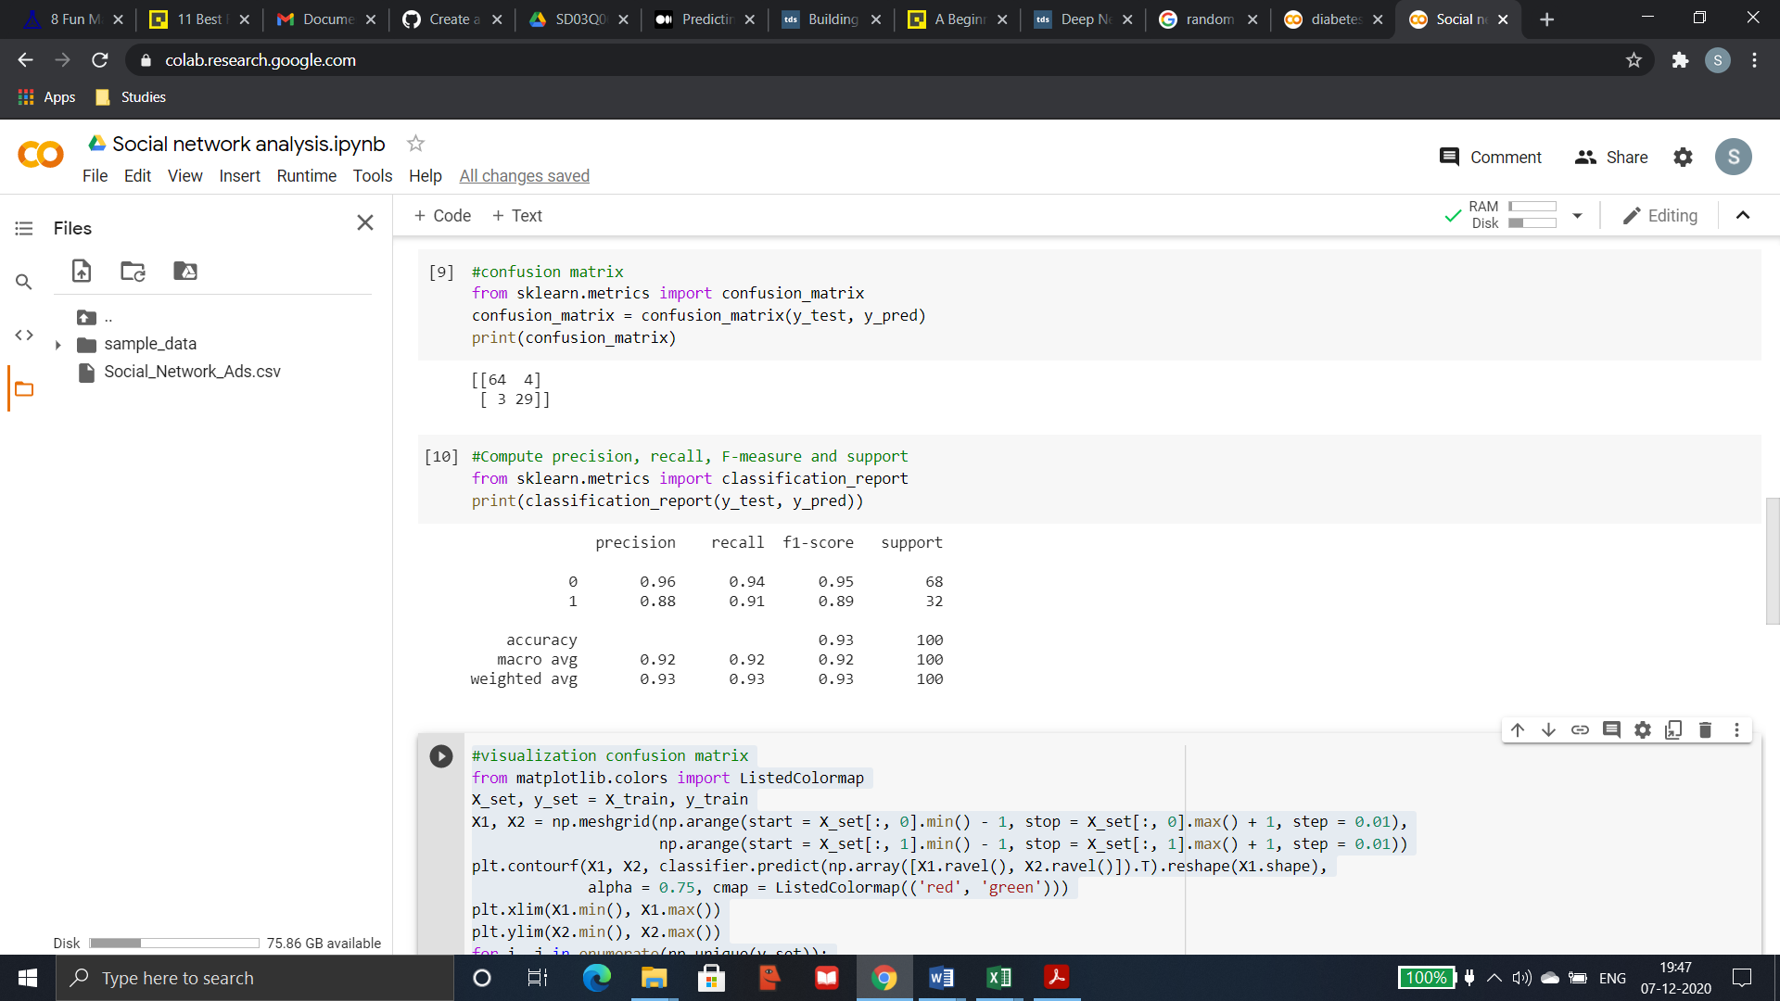

The output of the confusion matrix shows that 64+29 values are classified correctly as they are true positive and true negative values whereas 3+4 values are wrongly classified as they are false positive and false negative values.

Accuracy, Precision, Recall:



With the Accuracy of 93% and high Precision and Recall value it shows the KNN model fits well for classification and prediction of Social_Network_Ads.csv dataset.

**Visualization:**

Training set:

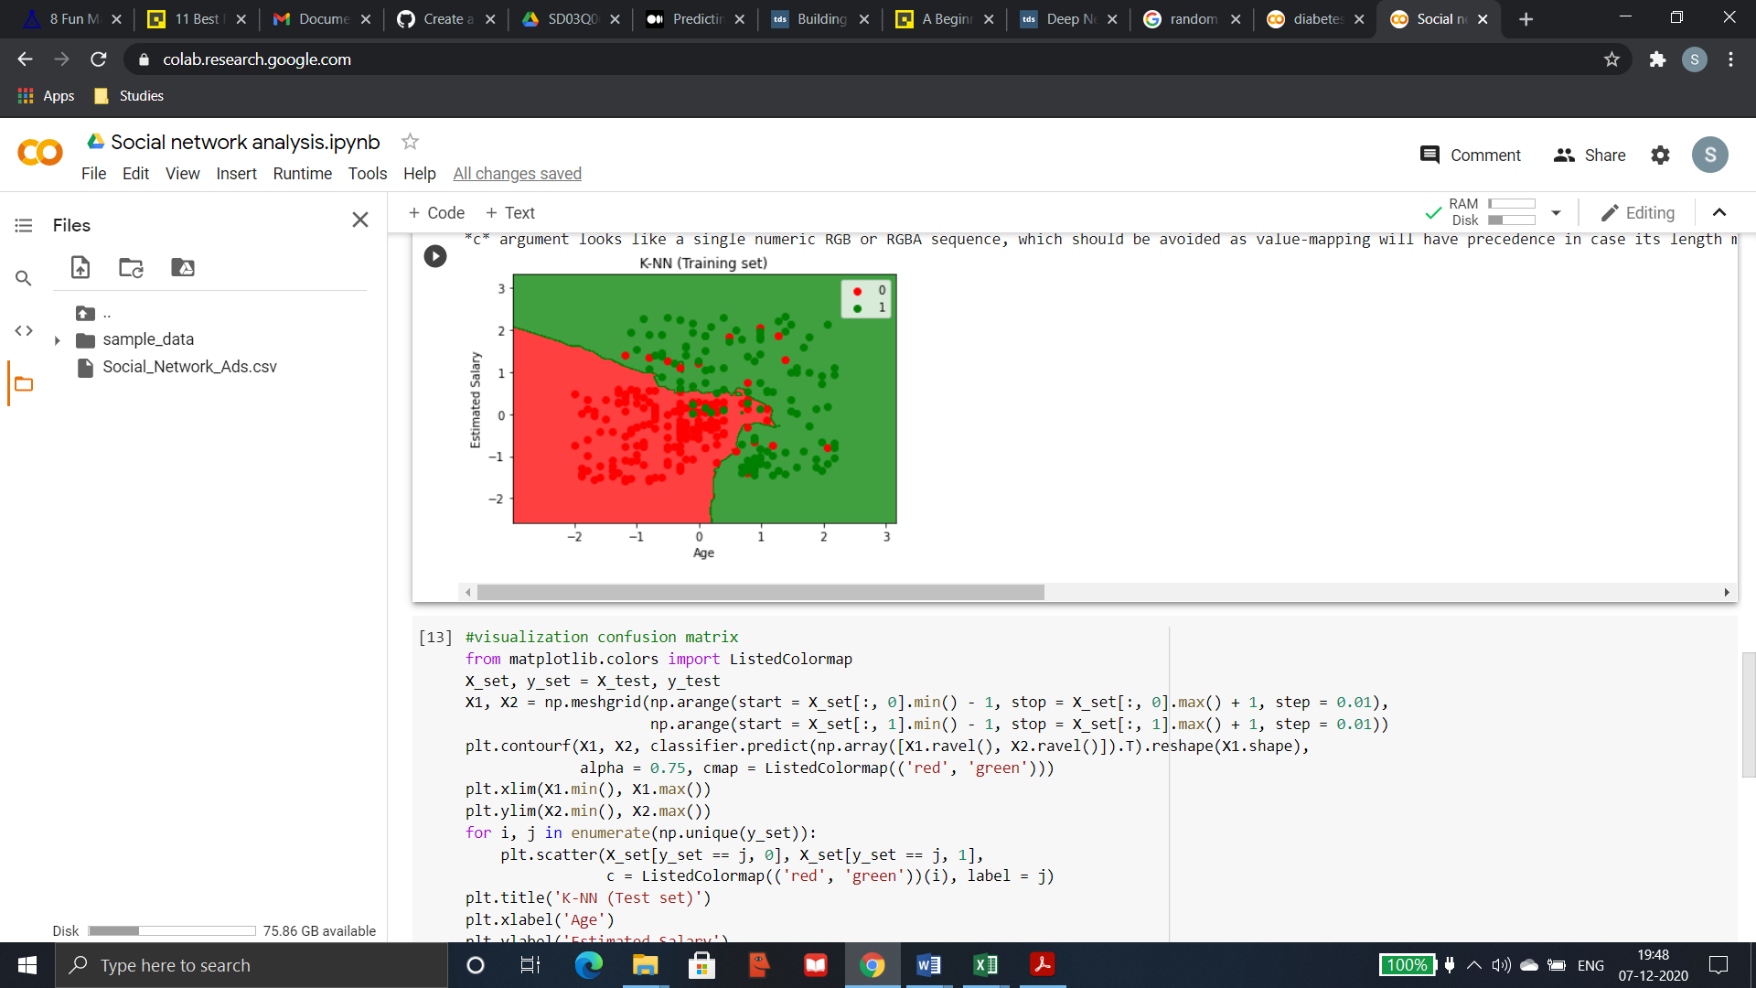

Test set:

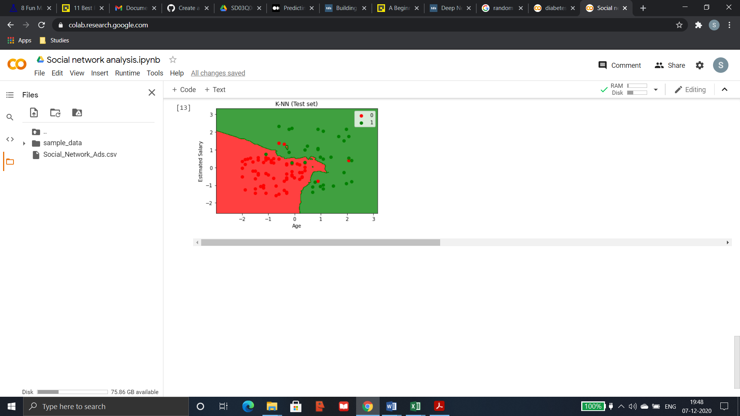

**Conclusion:**

The above results and visualization shows that KNN classifier model fits best for the given dataset.